The Big Ben!!

History:
The Big Ben is built in the year 1858, because fire destroyed the palace of Westminster. The choice was that on the place of the palace to building a giant clock. On 31 May was the first ring of the giant clock. The bells rang for the first time at 11 July 1859. After 150 years the clock stops for maintenance work.
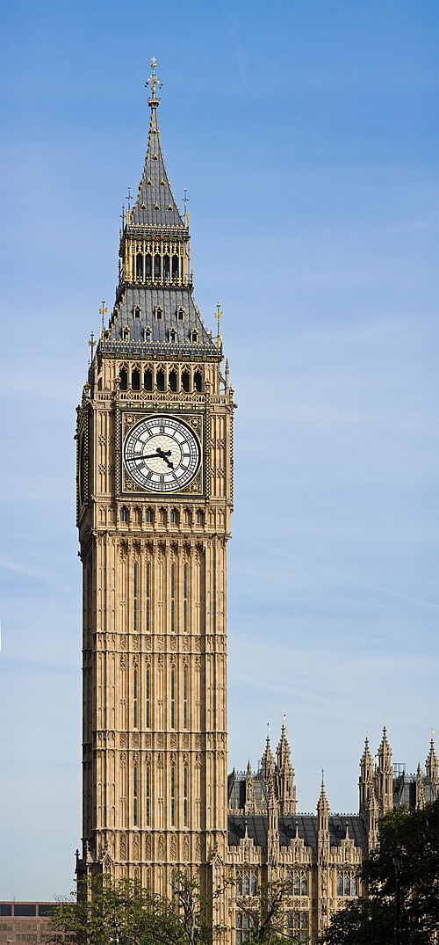
Two months later cracked the big ben. The bell was rotated en they choose to place a big hammer that wasn’t damaged when the bell was rotated.

The Big ben is a must see, because it is the largest four-dial clock in the whole world. After the big ben you can see the London eye. The bell inside the clock is 31.5 ton And the clock with the four dials has a diameter of 7 meters. The high of the clock is 69 meters.The name of the big ben comes from Benjamin Hall, The man who makes the installation of the giant clock. In the years 1939,1956 and 2009 was the clock cracked. Shortly after it was installed.

Address:
Parliament Square
Westminster
London
SW1P 3AD
The nearest tube to the Big Ben is the tube: SW1A. It’s three minutes from the Big Ben.

The opening times are:
Saturday, throughout the year 9.15am - 4.30pm. And there are tours from Monday to Friday. The times of the tours are: 9.30am, 10.30am, 11.30am & 2.30pm. Max. 16 people per tour.

The ticket price:
Adults: £15
Family: £37
Students: £10
OAP: £10,
Children 5-16: £6
Under 5 years: Free!

